National College of Computer Studies

Paknajol, Kathmandu

Project Work

On

MS-EXCEL

Submitted By: Submitted to:

Bishal Phuyal Mrs. Pratikshya Poudel

Class: BIM 1st Semester Mrs. Restha Kapali

Section: A

Roll no. 09

Date of Submission: 2020/10/03

Table of Contents

Introduction 1

Features of Microsoft Excel 2

History 3

Basic Layout of MS Excel 4

Lab sheet for Excel 5

Example 1 5

Example 2 6

Example 3 7

Example 4 9

Example 5 10

Example 6 11

Example 7 12

Example 8 13

Conditions 14

MS EXCEL

## Introduction

[Microsoft Excel is a spreadsheet](https://www.greycampus.com/blog/workplace-tools/five-excellent-basic-formatting-tips-on-ms-excel) program included in the Microsoft Office suite of applications. Spreadsheets will provide you with the values arranged in rows and columns that can be changed mathematically using both basic and complex arithmetic operations. In addition to the standard spreadsheet features, Excel offers programming support via Microsoft's Visual Basic for Applications (VBA), the ability to access data from external sources via Microsoft’s Dynamic Data Exchange (DDE). Microsoft Excel is an Electronic Spreadsheet Computer Program.

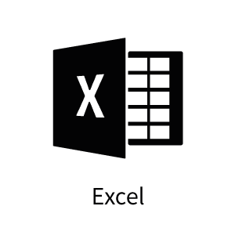

Fig: (Official logo of MS-Excel.)

The Excel spreadsheet app lets you create, view, edit, and share your files with others quickly and easily. Create spreadsheets, data analyses, charts, budgets and more while you view and edit workbooks attached to email messages. Edit documents for data analysis, accounting, finance, or any other fields with confidence. When on the go, your data and office move with you. Create charts, run data analysis and annotate your documents from your phone at any time. Create formulas and spreadsheets, review your charts or start a budget on the go. Make spreadsheets and data files your way with robust formatting tools and great features. Excel lets you build your charts and spreadsheets to meet your specific needs. Get data analysis, spreadsheets and business features of Microsoft Office on your phone with Microsoft Excel.

## Features of Microsoft Excel

## History

|  |  |  |  |
| --- | --- | --- | --- |
| **Year** | **Name** | **Version** | **Comments** |
| 1987 | Excel 2 | 2.0 | Renumbered to 2 to correspond with contemporary Macintosh version |
| 1990 | Excel 3 | 3.0 | Added 3D graphing capabilities |
| 1992 | Excel 4 | 4.0 | Introduced auto-fill feature |
| 1993 | Excel 5 | 5.0 | Included Visual Basic for Applications (VBA) and various object-oriented options |
| 1995 | Excel 95 | 7.0 | Renumbered for contemporary Word version. Both programs were packaged in Microsoft Office by this time. |
| 1997 | Excel 97 | 8.0 |  |
| 2000 | Excel 2000 | 9.0 | Part of Microsoft Office 2000, which was itself part of Windows Millennium (also known as "Windows ME"). |
| 2002 | Excel 2002 | 10.0 |  |
| 2003 | Excel 2003 | 11.0 | Released only 1 year later to correspond better with the rest of Microsoft Office (Word, PowerPoint, etc.). |
| 2007 | Excel 2007 | 12.0 |  |
| 2010 | Excel 2010 | 14.0 | Due to superstitions surrounding the number 13, Excel 13 was skipped in version counting. |
| 2013 | Excel 2013 | 15.0 | Introduced 50 more [mathematical functions](https://en.wikipedia.org/wiki/Function_(mathematics)) (available as pre-packaged commands, rather than typing the formula manually). |
| 2016 | Excel 2016 | 16.0 | Part of [Microsoft Office 2016](https://en.wikipedia.org/wiki/Microsoft_Office_2016) |

## Basic Layout of MS Excel

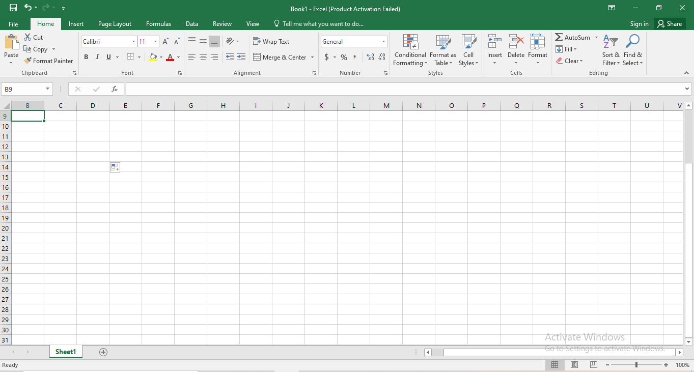

Fig:(Basic Playground of MS Excel)

## Lab sheet for Excel

### Example 1

Prepare a following stationary bill and calculate the total using formula.

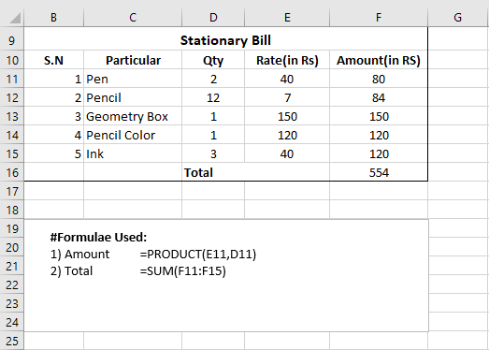

Fig:( Excel that shows the stationary Bill with total).

### Example 2

Find the following using excel formula.

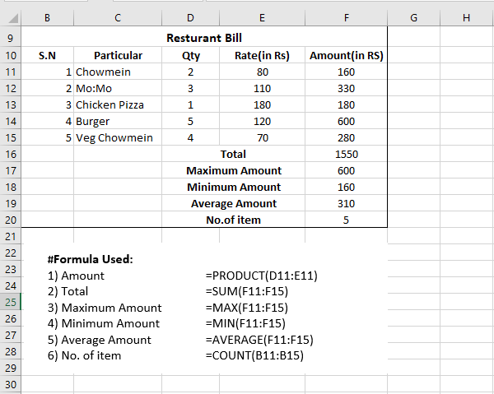

Fig:(Excel to find the Restaurant Bill with total, min, max, average, no of item.)

### Example 3

Draw a column chart, bar chart and line chart of following data.

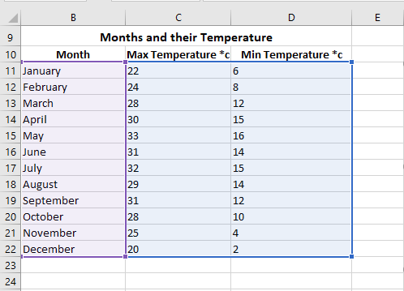

Fig:(Excel that lists Min and Max temperature of the months).

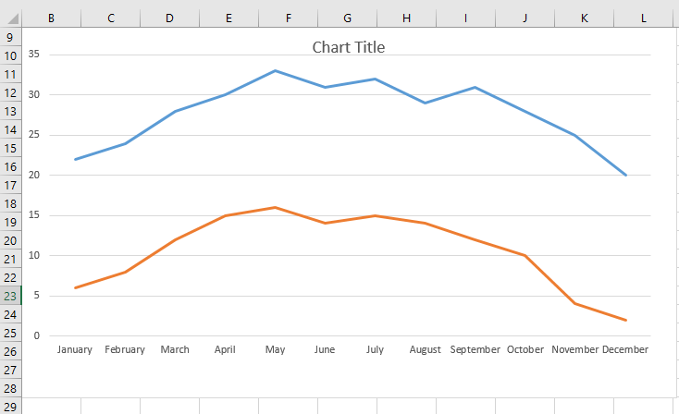

Fig: (Line chart for the above Temperature Lists.)

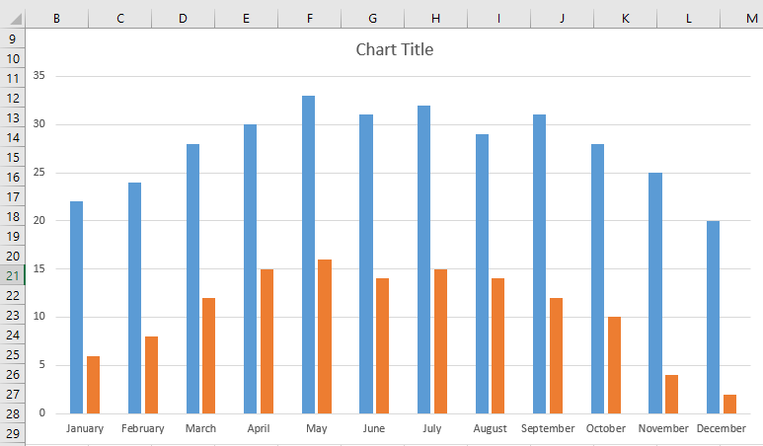

Fig:(Column Chart for the above Temperature lists)

### Example 4

Prepare a following data of student of your class. Find the following amount and also sort the name of students in ascending order.

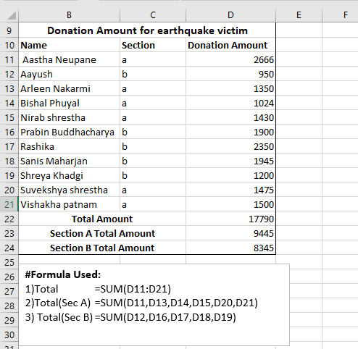

Fig: (Excel to show the Ascending Order, with Separate section Sum Amount.)

### Example 5

Find out the age of 10 people by using DOB. And also find the category of a person.

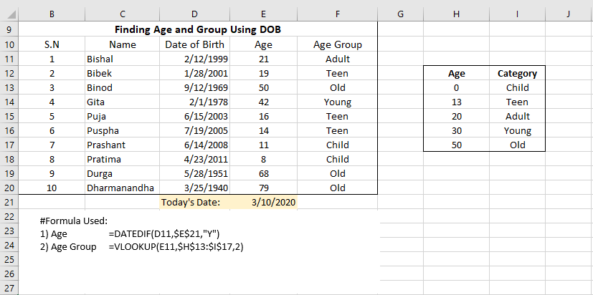

Fig:(Excel to find out the age and age group using DOB)

### Example 6

Create a Mark-Sheet of 10 students.

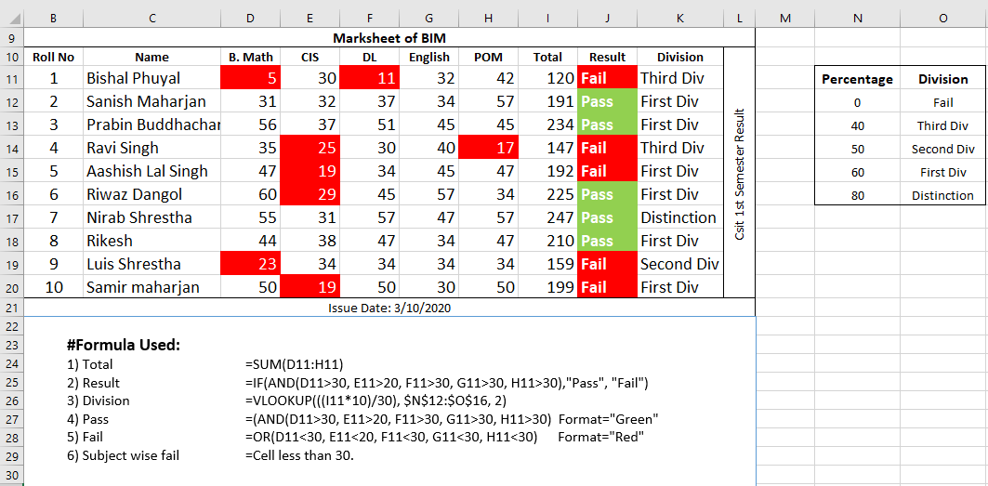

Fig:(Marks-Sheet of 10 BIM students with result and Division)

### Example 7

Create a salary sheet of 10 employees.

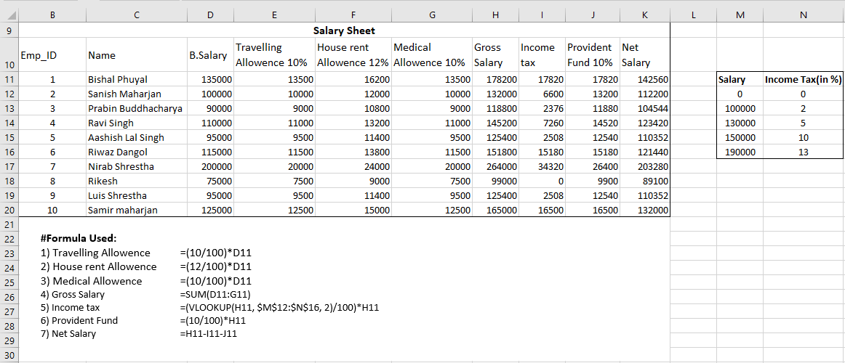

Fig:(Salary Sheet of Employee with different allowances and gross and net salary.)

### Example 8

Prepare a Tele-Communication Telephone bill of 10 customers.

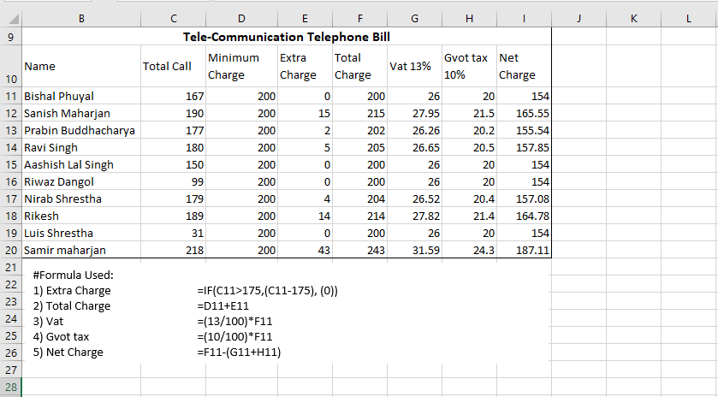

Fig:(Tele-Communication telephone Bill with ranges of tax and vat and net charges.) taxes.)

## Conditions

**Condition for Example 6:**

Percentage>=80 Distinction

Percentage>=60 First Division

Percentage>=50 second Division

Percentage>=40 Third Division

Percentage>=40 Fail

Indicate the marks with red color whose mark is less than 40. And highlight the Result “Pass” with green color and “fail” with red color.

**Condition for Example 7:**

B.Salary<3000 0% of B.Salary

B.Salary<5000 2% of B.Salary

B.Salary<100000 5% of B.Salary

B.Salary<15000 10% of B.Salary

B.Salary<15000 15% of B.Salary

**Condition for Example 8:**

Total calls<=175 is Rs.200

Otherwise Per call Rs.1